Eye Controlled Mouse Pointer

1Jaya Vardhan, 2Rohit, 3Girish, 4Balaji, 5Asst.Prof. Raghu Teja

Department of Computer Engineering, Geethanjali Institute of Science and Technology, Nellore, AndhraPradhesh, India.

***Abstract:*** This paper presents an eye gaze tracking system which has been developed to help physically challenged people for the readily access of a computer. The system is a computer interface which provides the function of a mouse, based on eye actions such as blink, gestures and gaze. The idea behind this system is to enhance the interaction of a person with the computer. Eye gaze tracking is a process of detecting and measuring the eye movements. This system explores the potential of the human eye gaze which can be used as a pointing device on the computer.

## *Index Terms* - Eye Gaze, Eye Localization, Face Detection, Mouse Pointer, Object Detection, Viola-Jones (VJ) Algorithm, Human-Computer Interaction.

1. **INTRODUCTION**

There are hundreds of cameras capturing our faces and using it for various purposes. Despite of such advancement in technology, there is no such proper system that can help physically challenged people for using a personal computer. The current systems which exist, help the users in controlling a desktop without the usage of their hands. But the major disadvantage of these systems is that, they are expensive. Our main objective is to make the system cost effective, so that the system is affordable. The main beneficiaries of our system will be the people who have physical impairment of their hands. Our proposed system will use the concepts of eye gaze, eye movement, head movement, blink detection to track the user’s eye.

## PROBLEM STATEMENT

Currently as today, there are around 21 million people in India who are suffering from one or more than one physical disabilities which constitutes around 2 percent of India’s population. In today’s era computers have become a significant part of our lives. Such people cannot readily use the computer system. Our problem is to develop a system which can help such people who are physically disabled but visually intact to use the computer system, so that their physical disability won’t hinder their abilities to use a computer.

## LITERATURE REVIEW

This section describes about our study of the existing systems which we have used as a reference for proposing our system. The system used in [1] consists of the face captured by the usage of Matlab vfm tool. The eye detection is done by dividing face into three equal regions and localizing the upper one-third part. The eye movements are tracked using the corners of the iris as reference and calculating the iris shift which helps in tracking of eye movement. This paper [2] contains an experimental procedure of webcam based eye-tracker especially for low powered devices. It consists of five processes which includes background suppression, haar cascade feature based face detection algorithm, geometrical determination of eye position, tracking of eye ball center using mean of gradient vector and detection of the user’s gaze. A novel eye movement analysis model is proposed in this paper [3] based on five eye feature points. In this paper Convolutional Neural Network is trained for eye feature point detection. Dataset was constructed containing almost 0.5 million frames from 38 subjects. This system [4] shows use of a commercial eye tracker as a peripheral device implementing it as pointer which only needs an eye movement of the user. The tests were conducted to check the discomfort and willingness of the subjects. The system implemented in [5] is used to perform gaze direction estimation from human eye movement using a consumer level depth sensor. The pre- processing of the images is done to remove the unnecessary information such as background objects. The proposed method obtains the position of the user’s head in depth images. The system [6] uses combination of head pose and eye location information to obtain enhanced gaze estimation. The transformation matrix which is obtained from the head pose is used to normalize the eye regions. The system in [7] is a computer interface that provides the functionality of an input device like mouse, based on eye actions such as eye blink, eye gaze and gaze control. The implemented system comprises of face detection using APIs, Forehead detection using Canny’s Edge detection, eye detection using Cross shaped model, morphological erosion which subdues speckle and jitter noise, smoothening of protrusions present around eye region, morphological dilation, eye detection, Gaussian filtering , iris detection and finally equalization. The system used in [8] consists of electro-oculography approach for analyzing the eye movements. It also uses Hough transform technique and canny edge detection. The illumination of the eyes is done using IR LED which is mounted on either sides of the camera lenses which is invisible to the naked eye and hence will not cause any strain to the user’s eyes.

## SYSTEM OVERVIEW

The system inputs the video frames from the user. The video is pre-processed for enhancement. In this process the noise and the blurriness of the video is handled. The face detection is carried out using the Viola-Jones algorithm. The procedure for further mouse pointer control will be done as follows:-

* Video stream will be captured through the webcam.
* The video input will be broken into frames.
* The frames captured will be in RGB mode. These frames will be converted to grayscale as the further processing will be easier using the grayscale conversion.
* The frames focusing the eyes are used for the detection of the corners of eye.
* The eye point is calculated and the mouse will move from one position to another based on the movements of this eye point.

## SYSTEM REQUIREMENTS

For the system, Python is used as a platform for the entire development purpose. OpenCV [12] library is useful for image processing and computer vision in Python. The system will be implemented with the help of this library. Along with that the other modules which will be used for implementation will be numpy, dlib, haar-cascade classifiers, pynput.

The users will need to have well-functioning computer system ensuring approximate RAM, processor, hard drive, monitor, webcam and OS requirements.

## PROPOSED METHODOLOGY

The system comprises of various phases including face detection, eye localization, iris detection, midpoint focus and mouse pointer control. The eye region is darker compared to the nose bridge region. This will be used as a distinguishing feature in the detection of the eyes from the face. The mouse left click event will occur if the eye is closed for at least five seconds. The system will display an error if no input is detected or the eye is closed for longer period of time which comprises of more than a minute of no activity.

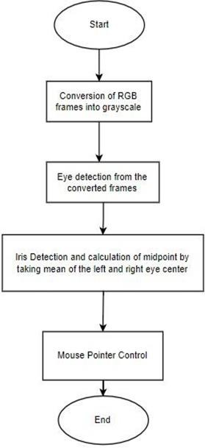

**Fig 1:** Feature Extraction for Eye Localization

The detection of eye is done using haar cascade classifier. Haar-like features are digital image features used in object detection. In the detection phase of the VJ object framework, a window of the target size is moved over the input image, and for each subsection of the image the Haar-like feature is calculated. This difference is then compared to a learned threshold that separates non-objects from objects. Because such a Haar-like feature [9] is only a weak learner or classifier (its detection quality is slightly better than random guessing) a large number of Haar-like features are necessary to describe an object with sufficient accuracy. In the Viola– Jones object detection framework, the Haar-like features are therefore organized in something called a classifier cascade to form a strong learner or classifier [11].

## Facial Landmark and Contour Detection

Dlib shape predictor has proven to be effective in facial landmark detection. Using the Dlib’s shape predictor we are able to extrapolate a set of 68 prime points from the face. The prime points which we are interested is the mouth and the eyes. The process is able to successfully extract the landmark indexes which are useful in classification of left and right eyes.The landmark prediction algorithm offered by Dlib is an implementation of the Ensemble of Regression Trees[14]. The dlib model is trained on iBug 300-W dataset [15]which is able to localize the facial landmarks. In our project we have used shape predictor 68 model for landmark detection.

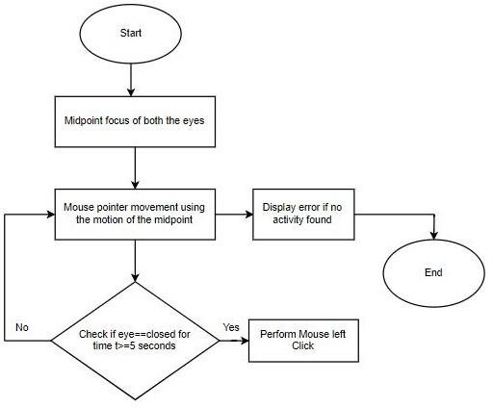

**Fig 2:** Mouse Pointer Control

## Mouse pointer automation using PyAutoGui

Pyautogui is python module which is useful in GUI automation. PyAutoGui is useful in controlling mouse actions and mapping them according to our requirements. The mouse movements are mapped according to the movements of the center of both the eyes and the click events are based on eye blinks. The left eye blink activity controls the left mouse click similarly the right eye blink is able to control the right mouse click.

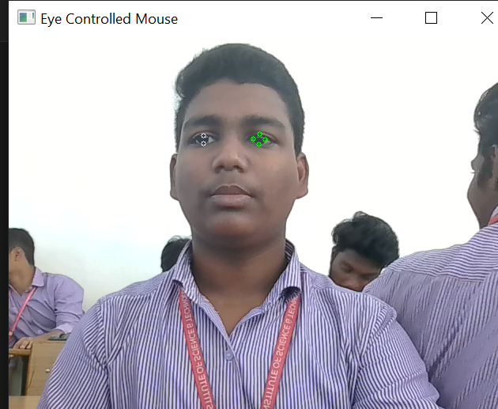

# CONCLUSION AND FUTURE SCOPE

The system works on the principle of object detection using VJ algorithm. The system can be useful for controlling the mouse pointer on the mere usage of the eyes. This system shall be useful for the usage of a personal computer for handicapped subjects. Our low-cost based system aims to be affordable for the majority of the physically disabled subjects.

**REFERENCES**

1. Nasor, Mohamed, et al. "Eye-controlled mouse cursor for physically disabled individual." Advances in Science and Engineering Technology International Conferences (ASET), 2018. IEEE, 2018.
2. Elahi, Hossain Mahbub, et al. "Webcam-based accurate eye-central localization." Robot, Vision and Signal Processing (RVSP), 2013 Second International Conference on. IEEE, 2013
3. Meng, Chunning, and Xuepeng Zhao. "Webcam-Based Eye Movement Analysis Using CNN." IEEE Access 5 (2017): 19581- 19587.
4. Cáceres, Enrique, Miguel Carrasco, and Sebastián Ríos. "Evaluation of an eye-pointer interaction device for human-computer interaction." Heliyon 4.3 (2018): e00574.
5. Tsai, Jie-Shiou, and Chang-Hong Lin. "Gaze direction estimation using only a depth camera." 2018 3rd International Conference on Intelligent Green Building and Smart Grid (IGBSG). IEEE, 2018.
6. Valenti, Roberto, Nicu Sebe, and Theo Gevers. "Combining head pose and eye location information for gaze estimation." IEEE Transactions on Image Processing 21.2 (2012): 802-815.
7. Hegde, Veena N., Ramya S. Ullagaddimath, and S. Kumuda. "Low cost eye based human computer interface system (Eye controlled mouse)." India Conference (INDICON), 2016 IEEE Annual. IEEE, 2016.
8. Prof. Prashant Salunkhe, Miss. Ashwini R Patil “A Device Controlled Using Eye Movement”, International Conference on Electrical, Electronics, and Optimization Techniques (ICEEOT) 2016.
9. Haar-like features h ttps://en.wikipedia.org/wiki/Haar- l ike_feature
10. Tobii Technology h ttps://[www.tobii.com/](http://www.tobii.com/)
11. Viola-Jones object detection framework https://en.wikipedia.org/wiki/Viola-J ones_object_detection_framework.
12. OPENCV h ttps://opencv.org
13. PyImageSearch https://[www.pyimagesearch.com](http://www.pyimagesearch.com/)
14. https://github.com/davisking/dlib
15. https://ibug.doc.ic.ac.uk/resources/300-W/